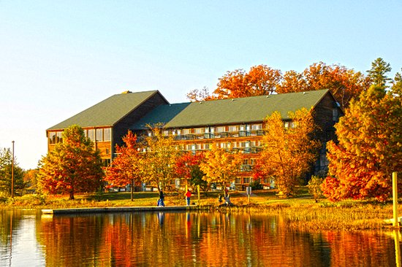

2023 Joint Retreat
YMCA Trout Lodge
November 9-10

Department of Cell Biology & Physiology

Molecular Cell Biology Program

Washington University School of Medicine

Agenda

Thursday, November 9th
10:30 AM
Welcome Introduction from Dr. Sheila Stewart, Dr. Roberta Faccio, & Dr. Zhongsheng You
(Mallard Room)
10:35 AM – 12:00 PM
Student Speaker Session One
(Mallard Room)
12:00 – 1:30 PM
Check-In & Lunch
(Dining Hall)
1:30 – 3:00 PM
Break
3:00 – 4:25 PM
Student Poster Session 1
(Mallard Room)
4:25 – 4:35 PM
GR1 Introduction
(Mallard Room)
4:35 – 6:00 PM
Student Poster Session 2
6:00 – 7:00 PM
Dinner
(Dining Hall)
7:00 – 8:00 PM
Faculty Lightning Talks
(Mallard Room)
8:00 – 9:00 PM
Faculty Posters
8:00 – 9:30 AM
Friday, November 10th
8:00 – 9:39 AM
Breakfast & Faculty Round Tables
(Mallard Room)
9:30-10 AM
Group Photo
10:00 – 11:30 AM
Student Speaker Session Two
(Mallard Room)
12:00 – 1:00 PM
Lunch
(Dining Hall)
1:00 – 1:30 PM
Student Talk & Poster Winners
(Dining Hall)
1:30 - 3:00 PM
Check-Out
---------------------------------
Round Table Topics
- How to find a job
- Shared resources & scientific collaborations
- Where’s my name? Discussing authorships
- My PI won’t let me take my project! The path towards independence
- Speak up! Bringing up difficult topics, self-promotion, and asking for what you need
- Am I good enough? Let’s talk imposter syndrome
- How to choose a rotation lab

(Hillcrest Hall)
9:00 – 11:00 PM
Bonfire
(Panabaker Firepit)

Faculty Lightning Talks

- Chun-Kan Chen (CBP)
- Leslie Gewin (MCB)
- Polina Lishko (CBP)
- Xue-Yan He (CBP)
- Priyanka Verma (MCB)
- Jose Saenz (MCB)

Faculty Poster Presenters

- Amber Stratman (CBP)
- Chun-Kan Chen (CBP)
- Clair Crewe (CBP)
- David Kast (CBP)
- Eric Greer (MCB)
- Gabor Egervari (MCB)
- Jose Saenz (MCB)
- Slavic Pavlovic-Djuranovic (CBP)
- Yoon-A Kang (MCB)
- Luis Bastista (MCB)
- Nathaniel York (CBP)
- Roberta Faccio (MCB)
- Siyuan Ding (MCB)
- Stephen Kerry Kornfeld (MCB)
- Sun Joo Lee (CBP)
- Zhongsheng You (CBP)
- Xue-Yan He (CBP)

Student Poster Presenters

Session One Session Two
- Andrew Smith (Pagliarini Lab)
- Caroline Fecher (Pagliarini Lab)
- Chen Cheng (You Lab)
- DeHaven McCrary (Jansen Lab)
- Dhaval Bhatt (Major Lab)
- Dymonn Johnson (Stratman Lab)
- Emily Eul (Faccio Lab)
- Emma Bartley-Dier (Cohen Lab)
- Geralle Powell (Pavlovic-Djuranovic Lab)
- Harit Panda (Major Lab)
- Ilah Bok (Major Lab)
- Isaac Plutzer (Major Lab)
- Javier Abello (Stratman Lab)
- Jessey Erath (Pavlovic-Djuranovic Lab)
- Jennifer Ye (Stewart Lab)
- Kyle LaPak (Major Lab)
- Marion Stunault (Ashrafi Lab)
- Meg Schuetz (Kast Lab)
- Meizi Liu (Diamond Lab)
- Qingwei Niu (Lishko Lab)
- Rachel Guerra (Pagliarini Lab)
- Rosa Scala (Nichols Lab)
- Sarah Colijn (Stratman Lab)
- Taylor Malachowski (Stewart Lab)
- Tessa Lochetto (Niemi Lab)
- Victoria Ismail (Kast Lab)
- Xiaoyu Yuan (Stewart Lab)
- Zakery Baker (Pagliarini Lab)

Student Speakers: Session One
10:30 – 10:45 AM
Jennifer Ye (Stewart Lab)
10:45 – 11:00 AM
Julius Chembo (Major Lab)
11:00 – 11:15 AM
Hannah Lynn (Gordon Lab)
11:15 – 11:30 AM
Isaac Plutzer (Major Lab)
11:30 – 11:45 AM
Carolyn Lazaroff (Faccio Lab)
11:45 – 12:00 PM
Tessa Lochetto (Niemi Lab)

Student Speakers: Session Two
10:00 – 10:15 AM
Qingwei Niu (Lishko Lab)
10:15 – 10:30 AM
Sarah Colijn (Stratman Lab)
10:30 – 10:45 AM
Meizi Liu (Diamond Lab)
10:45 – 11:00 AM
Eddie Rashan (Pagliarini Lab)
11:00 – 11:15 AM
Wentao Han (Challen Lab)
11:15 – 11:30 AM
Elisha Mugo (Pavlovic-Djuranovic Lab)

