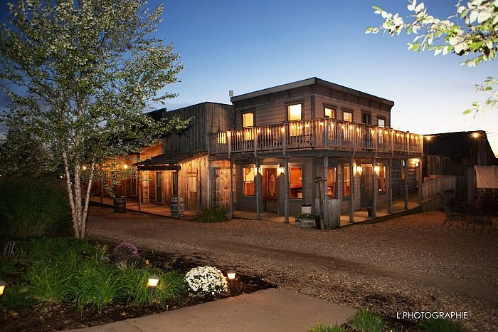  2022 Joint Retreat  Cedar Creek Resort  September 15-16  Department of Cell Biology and Physiology  Molecular Cell Biology Program  Washington University School of Medicine | Thursday, September 15th  10:00 AM – 12:00 PM Speaker Session One (Event Barn)  12:00 – 1:30 PM Lunch & Check-In (Town Hall/Saloon)  1:30 – 2:45 PM Poster Session One (Event Barn)  2:45 – 4:30 PM Break  4:30 – 6:00 PM Cocktails (Town Hall)  6:00 – 7:00 PM Dinner (Event Barn)  7:00 – 8:00 PM Faculty Lightning Talks (Event Barn)  8:00 – 9:00 PM Faculty Posters (Event Barn)  9:00 – 11:00 PM Trivia & Smores (Western Town)  Friday, September 16th  8:00 – 8:45 AM Breakfast (Town Hall)  8:45 – 9:00 AM  Group Photo (Event Barn)  9:00 – 11:00 AM Speaker Session Two (Event Barn)  11:00 AM – 12:00 PM Poster Session Two & Awards (Event Barn)  12:00 – 3:00 PM Box Lunches & Breakouts (Cedars Meeting Room)  3:00 PM Check-Out

Faculty Lightning Talks
Moderator: Douglas Faget (CBP – Stewart Lab)

- Clair Crewe (CBP)
- Abby Green (MCB)
- Ghazal Ashrafi (CBP)
- Tao Che (MCB)
- Slavica Pavlovic-Djuranovic (CBP)
- Yoon-A Kang (MCB)
- Dave Pagliarini (CBP)
- Tony Tsai (MCB)

Faculty Poster Presenters

- Rajendra Apte (MCB)
- Luis Batista (MCB)
- Kendall Blumer (CBP)
- Jaehyung (Gus) Cho (MCB)
- Clair Crewe (CBP)
- Sergej Djuranovic (CBP)
- Roberta Faccio (MCB)
- Andreas Herrlich (MCB)
- Silvia Jansen (CBP)
- David Kast (CBP)
- Sun Joo Lee (CBP)
- Ben Major (CBP)
- Dave Piston (CBP)
- Maria Remedi (MCB)
- Sheila Stewart (CBP)
- Amber Stratman (CBP)
- Zhongsheng You (CBP)

Poster Presenters
Session One Session Two
- Javier Abello (Stratman Lab)
- Darby Agovino (Batista Lab)
- Abigail Bartlett (Pagliarini Lab)
- Ankan Bhadra (True Lab)
- Esmeralda Castleblanco (Remedi Lab)
- Julius Chembo (Major Lab)
- Chen Cheng (You Lab)
- Samantha Chin (Jansen Lab)
- Jason Colasanti (Apte Lab)
- Ariella Coler-Reilly (Civitelli Lab)
- Sarah Colijn (Stratman Lab)
- Sanchari Datta (Pagliarini Lab)
- Caroline Fecher (Pagliarini Lab)
- Patrick Forny (Pagliarini Lab)
- Rachel Guerra (Pagliarini Lab)
- Victoria Ismail (Kast Lab)
- Dymonn Johnson (Stratman Lab)
- Courtney Jungers (Djuranovic Lab)
- Nathaniel York (Nichols Lab)
- Kyle LaPak (Major Lab)
- Hannah Lynn (Gordon Lab)
- Taylor Malachowski (Stewart Lab)
- Jonathan Mount (Yuan Lab)
- Dave Pagliarini (Pagliarini Lab)
- Sumit Patel (Remedi Lab)
- Qihao Ren (Stewart Lab)
- Sean Rogers (Pagliarini Lab)
- Marion Stunault (Ashrafi Lab)
- Ke Tan (You Lab)
- Tyson Todd (Blumer Lab)
- Xue Wen Ng (Piston Lab)
- Zheng Yang (You Lab)
- Jennifer Ye (Stewart Lab)
- Emily Wilkerson Zarbock (Major Lab)
- Jian Gao (Nichols Lab)
- Dhaval Bhatt (Major Lab)
- Danielle Kemper (Djuranovic Lab)
- Douglas Faget (Stewart Lab)

Speaker Session One
Moderators: Kyle LaPak (CBP - Major Lab), Carolyn Lazaroff (MCB)

10:00 – 10:15 AM
Anupama Tiwari (Ashrafi Lab): The role of mitochondrial sirtuin 3 in the metabolic plasticity of synaptic transmission
10:15 – 10:30 AM
Juhee Son (Ding Lab): Inactivated rotavirus causes diarrhea through interferon-λ signaling in the intestinal epithelium
10:30 – 10:45 AM
Courtney Jungers (Djuranovic Lab): Cell specific contribution of AU-rich elements on microRNA-mediated gene repression
10:45 – 11:00 AM
Emily Eul (Faccio Lab): Bone-derived Dickkopf-related protein 1 supports hematopoietic stem cells during tumor progression
11:00 – 11:15 AM
Victoria Ismail (Kast Lab): The NTPase activity of the double FYVE domain containing protein 1 (DFCP1) regulates lipid droplet metabolism
11:15 – 11:30 AM
Brian Egan (Kornfeld Lab): ACN-1, the nematode homolog of the angiotensin-converting enzyme, regulates aging in Caenorhabditis elegans
11:30 – 11:45 AM
Nathan Wamsley (Major Lab): Improved targeted proteomics of MRF2 signaling and prognostic biomarkers in HNSCC
11:45 – 12:00 PM
Marcos Matamoross (Nichols Lab): Selectivity filter dynamics in a potassium selective and non-selective channels

Speaker Session Two
Moderators: Andrew Smith (CBP - Pagliarini Lab), Kyle Cotter (MCB)

9:00 – 9:15 AM
Zakery Baker (Pagliarini Lab): Multi-omic analyses of mitochondrial stress reveals a novel RNA binding protein involved in maintaining organellar function
9:15 – 9:30 AM
Jeongmin Lee (Piston Lab): The potential beneficial effect of brown adipocyte secreted factors on type 1 diabetes mellitus
9:30 – 9:45 AM
Qihao Ren (Stewart Lab): Investigating the intrinsic and extrinsic factors regulating breast cancer dormancy
9:45 – 10:00 AM
Taylor Malachowski (Stewart Lab): A role for senescence in chemotherapy induced neuropathy
10:00 – 10:15 AM
Dymonn Johnson (Stratman Lab): Regulation of endocytic trafficking and VEGFR2 receptor availability by a component of the microtubule motor dynein
10:15 – 10:30 AM
Lingzhen Kong (You Lab): TCAF1 controls TRPV2-mediated Ca²⁺ release from the ER for the protection of stressed DNA replication forks
10:30 – 10:45 AM
Sarah Koester (Dougherty Lab): Understanding the regulation of local translation in astrocytes
10:45 – 11:00 AM
Hannah Lynn (Gordon Lab): Development of microbiota directed complementary foods for treating childhood malnutrition

